RAIN WATER HARVESTING SYSTEM FOR TROPICAL REGION (RAIN-VEST-TROGION)
RESEARCHER: LIM KIM FAT
DEPARTMENT: CIVIL ENGINEERING
POLYTECHNIC: POLITEKNIK PORT DICKSON
EMAIL: limkimfat9898@gmail.com
CO-RESEARCHERS: MOHD RAZAK BIN ZAINUDIN
RAHIMAH BT OTHMAN
MOHD ARIF BIN GHAFAR
SUPERVISOR: EN. ZAMRI BIN KHAMIS

Research Background (Latarbelakang kajian)
- Infographic/Picture
- Text In Bullet Form
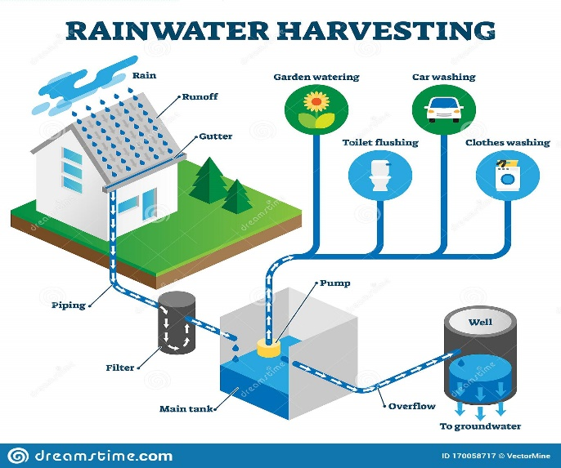
Materials and Methods
(Bahan dan Kaedah Kajian)
- Infographic/Picture
- Flowchart (If Necessary)

Properties | Location A | Location B | Location C
Specific Gravity | 2.77 | 1.72 | 1.86
Water absorption (%) | 0.8 | 12.3 | 10.78
Permeability (cm/s) | 5.49 | 5.34 | 0.29
Reseach Aim and Objectives
(Matlamat dan tujuan kajian)
- Text In Bullet Form
- Text In Bullet Form

Table 1: XXXXXXXXXX
Scope and Limitations
(Skop dan Batasan)
- Text In Bullet Form
- Text In Bullet Form

Figure 3: XXXXXXXXXX
Results and Discusions
(Hasil Kajian dan Perbincangan)
- Tables
- Graphs
- Text In Bullet Form

Acknowledgement
(Penghargaan)
- Text In Bullet Form
- Text In Bullet Form

Problem Statement
(Penyataan Masalah)
- Text In Bullet Form
- Text In Bullet Form

Figure 1: XXXXXXXXXX
Figure 2: XXXXXXXXXX
Conclusion and Recommendations
(Kesimpulan dan Cadangan)
- Tables
- Text In Bullet Form

